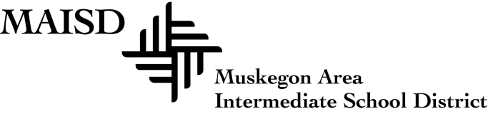
630 Harvey Street
Muskegon, Michigan 49442-4278
Phone 231-777-2637 Fax 231.773.1028
www.muskegonisd.org

April 15, 2016

Dear Parents and Community Members:
We are pleased to present you with the Annual Education Report (AER), which provides key information on the 2014-15 educational progress for the Muskegon County Juvenile Transition Center. The AER addresses the complex reporting information required by federal and state laws. The school’s report contains information about student assessment, accountability, and teacher quality. If you have any questions about the AER, please contact James Mueller, Coordinator for Nontraditional Programs, for assistance.
The AER is available for you to review electronically by visiting MI School Data, or you may review a copy in the facility office.
State law requires that we report the following additional information:
Process for Assigning Pupils to the School:
Muskegon County Juvenile Transition Center students are referred to the Center by Family Court or one of its designees. Only youth who are accused of or adjudicated for law violations are placed in Transition.
Status of the 3 – 5 Year School Improvement Plan:
In accordance with the Michigan Department of Education’s framework for continuous improvement, the staff works together to conduct data-based needs assessments which identify strengths and weaknesses with the instructional program. From the needs assessments, goals and objectives are developed in a detailed plan that is carried out over the course of 3-5 years. The plans are revised and adjusted annually through the School Improvement process.
Accessing the Learning Standards Upon Which Curriculum is Derived:
The Michigan State Board of Education has adopted the Common Core Standards for K-12 schools. To view these standards, along with the existing Grade Level Content Expectations/High School Content Expectations, please visit the Michigan Department of Education’s Academic Standards page.

Aggregate Achievement Results from Local Competency Tests or Nationally Normed Achievement Tests:
N/A
Number & Percentages of Students Represented by Parents/ Guardians at Parent/Teacher Conferences:
N/A
Dual Enrollment/College Equivalent Courses:
N/A
The Muskegon County Juvenile Transition Center functions under the auspices of the Muskegon County Department of Corrections and works collaboratively to provide educational programs and services designed to improve the quality of life for the students that are housed there
Sincerely,

James Mueller
Coordinator of Nontraditional Programs

